Press information

AMAZONE and AGRAVIS start a joint agricultural pilot project, Controlled Row Farming (CRF)
Row-based cultivation focusing particularly on biodiversity

In collaboration with AGRAVIS Raiffeisen AG and SCHMOTZER Hacktechnik, AMAZONEN-WERKE will start new long-term field trials in 2020. Entitled "Controlled Row Farming" (CRF), a completely new arable farming system will be introduced, in which each crop cultivation measure takes place in relation to a fixed row.

The vision of the CRF agro-ecological farming system consists in the needs-based use of resources to generate reasonable yields and profits together with the maximum contribution to biodiversity. The aim is to actively promote biodiversity and achieve sustainable agricultural returns at the same time. Both goals should not only be met but ideally also support each other.

All crop plants are grown at a row spacing of 50 cm in the CRF concept, whereby cereals are sown in double rows. Depending on the crop rotation, the row can be offset by 25 cm, in order, for example, to make use of the agronomical effect of the preceding undersown crop. Sowing is normally carried out in combination with row-oriented fertilisation. Plant protection is primarily applied row-specifically by means of band application on the row and via Dropleg systems at later growth stages. Each pass is always carried out with high-precision track guidance via RTK-GPS and camera control.

Hoeing technology is used for mechanical weed control in combination with row-specific plant protection, targeted fertiliser application and sowing of companion plants between the rows. These companion plants – without direct contact with fertiliser and plant protection agents – make a positive contribution to the phytosanitary support of the main crop as well as soil fertility and biodiversity. Depending on the crop and weather conditions, these companion plants are actively managed, in order to ensure the crop is harvested.

Two different intensities will be compared in the CRF trials: One variant will put the emphasis on the maximum yield with limited competition from companion plants. The second variant will focus on biodiversity with reduced intensity of fertiliser and plant protection measures. The two CRF variants will be compared with two intensity levels of usual soil management.

The 10 ha test area at Amazone’s Wambergen test centre is located in the direct vicinity of the main Amazone factory in Hasbergen-Gaste. The six-year crop rotation with cereals and maize is typical for the region. It consists of the establishment of rape and pulses as well as intensive catch crop cultivation in accordance with the principles of sustainability. A good basis for an intense exchange of experience with the practitioners will be established with the simultaneous cultivation of four crops in four variants on one area.

The agricultural experts and design engineers at AMAZONEN-WERKE and SCHMOTZER Hacktechnik will develop and test new technologies and tools in the trials. The arable farming advisers at AGRAVIS will provide their expertise to help select the right varieties and inputs for the CRF system. The experts at AGRAVIS Digital GmbH and AGRAVIS Technik will also provide support in the selection of new methods and technologies. It goes without saying that the utilisation and testing of a variety of digital methods from field surveying and the use of machinery to assessment of the crops and evaluation of the yields is part of the CRF project.

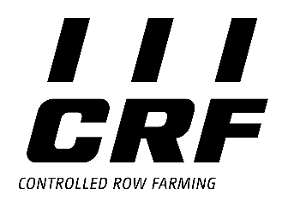
Further information is available at:
www.controlled-row-farming.com

Münster, Hanover and Hasbergen-Gaste, July 2020

AMAZONEN-WERKE H. Dreyer GmbH & Co.KG, with headquarters in Hasbergen-Gaste, not far from Osnabrück in Germany, manufactures agricultural and groundcare machinery. The owner-managed company employs around 1900 people across nine different production sites in Germany, France, Russia and Hungary.
The product range includes soil tillage implements, seed drills, fertiliser spreaders and plant protection equipment. The development, production and sales departments of Schmotzer Hacktechnik have been part of AMAZONEN-WERKE since 2019.
Based on these core competencies, AMAZONE is now the specialist for intelligent crop production in arable farming. AMAZONE has an excellent reputation among its customers thanks to its excellent quality and innovative products. www.amazone.net

AGRAVIS Raiffeisen AG is a modern agricultural trading company in the agricultural products, animal feed, crop production and agricultural engineering sector. It also operates in the energy and cooperative market sectors, including building supplies stores and construction projects. With around 6,500 employees, the AGRAVIS Group generates sales of 6.5 billion euro. It operates primarily in Germany and is a leading company in the sector with more than 400 locations. International activities are transacted through subsidiaries and affiliated companies in more than 20 countries, with exports going to more than 100 countries throughout the world. Its registered offices are located in Hanover and Münster. www.agravis.de

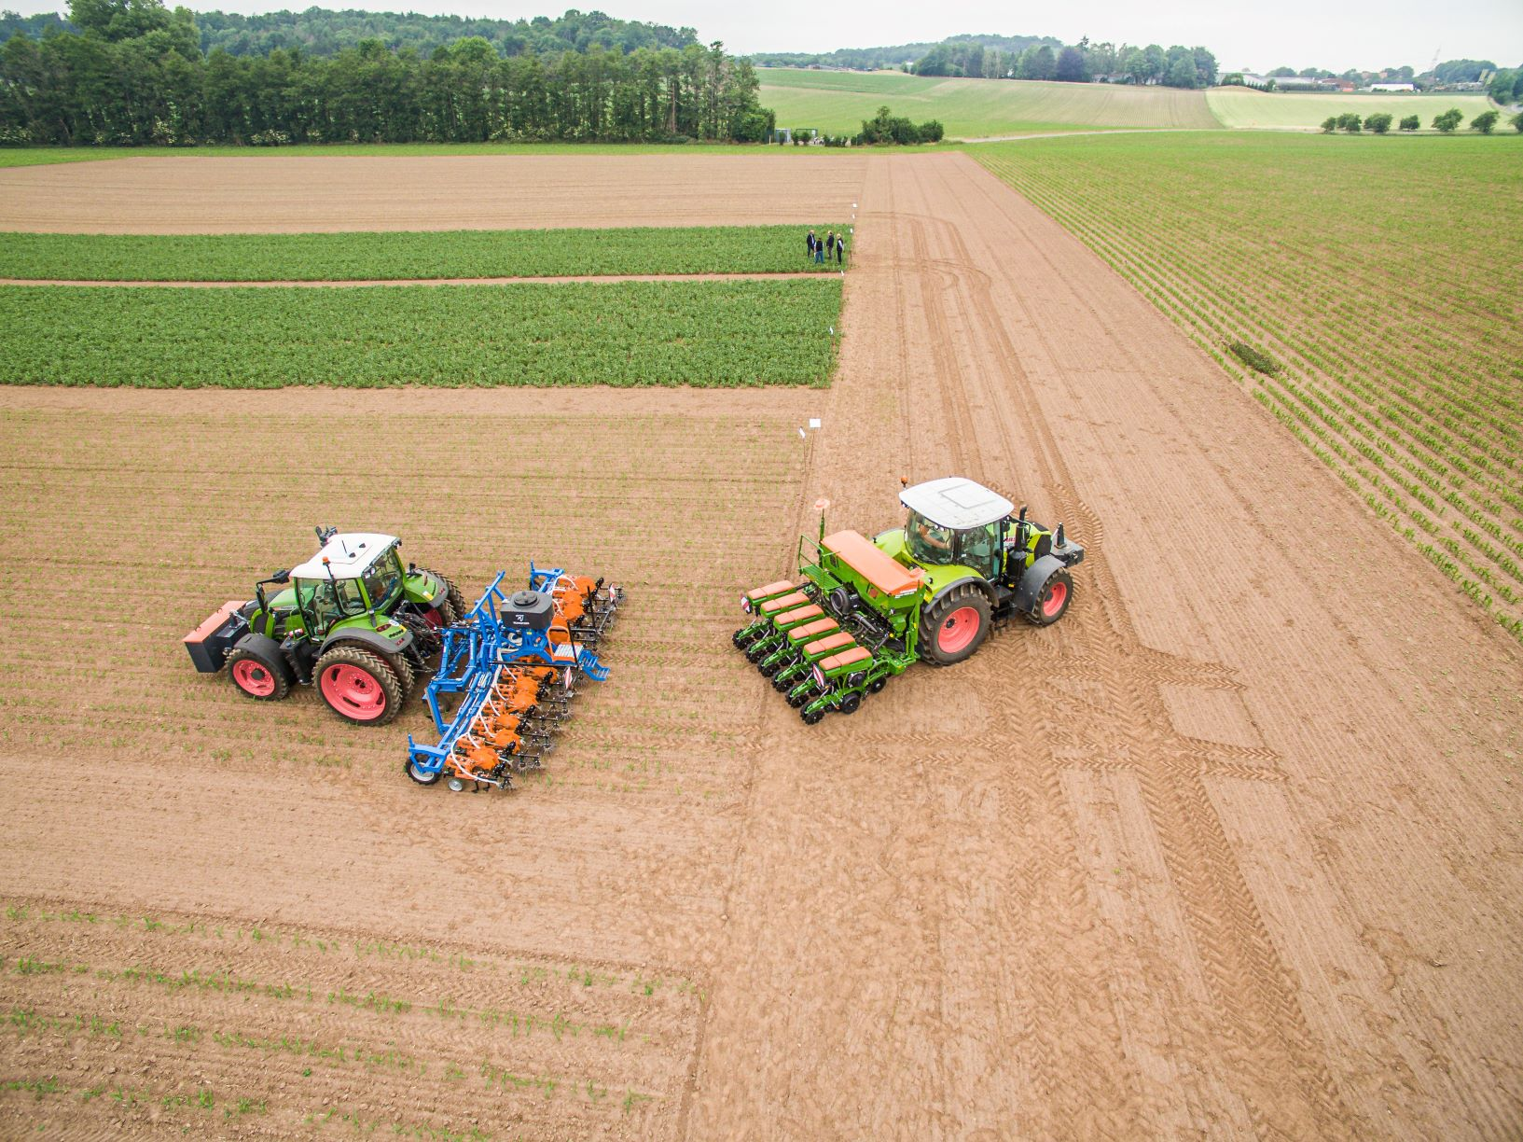

The spacious trials area is located in the direct vicinity of AMAZONEN-WERKE in Hasbergen-Gaste near Osnabrück.

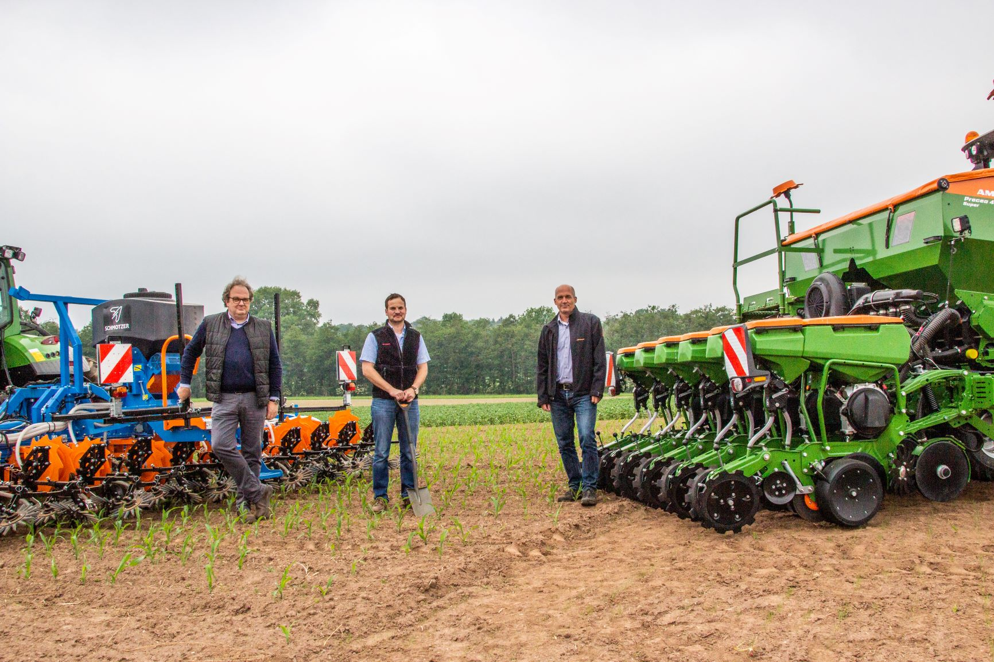

Carrying out the pilot project (from left to right): Franz Schulze Eilfing from AGRAVIS Raiffeisen AG, Farmer Hanno Haselroth and Stefan Kiefer from AMAZONEN-WERKE.
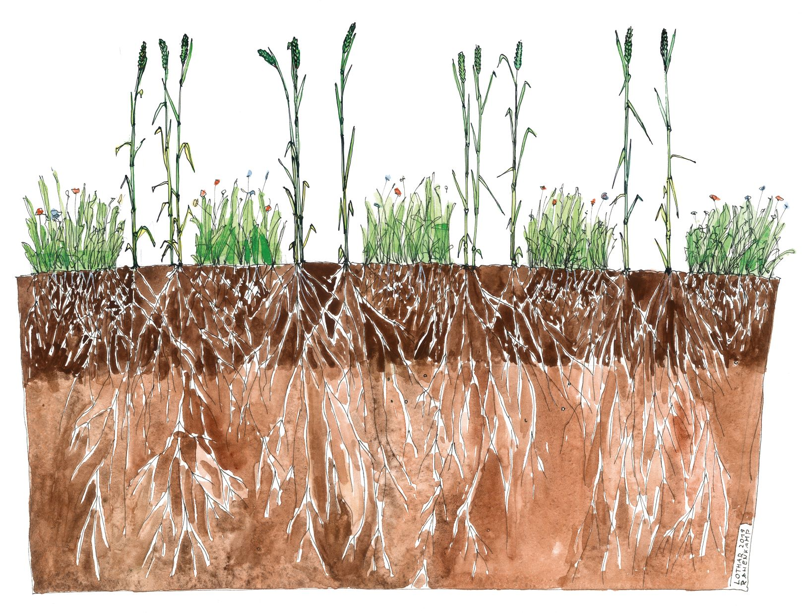
Illustration of cereals drilled in a double row with companion plants.

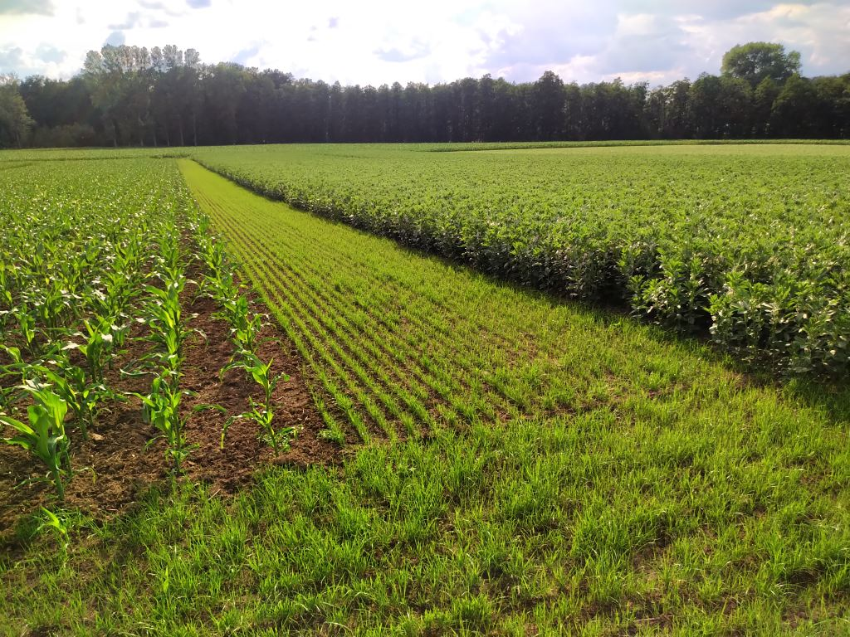

Maize and beans in the first trial plots in 2020 – the grass strip for walking around the field has already been laid.

